

**AMERICAN INTERNATIONAL UNIVERSITY–BANGLADESH (AIUB)**

**FACULTY OF SCIENCE & INFORMATION TECHNOLOGY**

**INTERNSHIP AFFILIATION REPORT ON**

***Intern Student at American International University –Bangladesh***

An Internship Report Presented to the

OFFICE OF PLACEMENT and

DEPARTMENT OF COMPUTER SCIENCE

In Partial Fulfillment of the Requirements for the Degree

***Bachelor of Science in Computer Science & Engineering***

**Supervised By**

**DR. Ashraf Uddin**

**Assistant Professor**

**Faculty of Computer Science**

**Submitted By**

**Rifat-Uz-Zaman, Md., 18-38024-2**

FALL 2021-2022

Date of Submission: **November 25, 2021**

# LETTER OF SUBMITTAL

25th November 2021

To,

DR. Ashraf Uddin

Assistant Professor

Faculty of Computer Science

American International University -Bangladesh (AIUB)

**Subject:** Submission of Internship Report on Intern Student at American International University-Bangladesh (AIUB).

Dear Sir,

This is my enormous pleasure to submit my internship report on “Intern Student at American International University – Bangladesh”. In this intern report, I have tried my best to relate all my experiences what I gained during the internship.

I was appointed as an Intern Student in the Department of Computer Science at American International University-Bangladesh under the supervision (industry) of Rezwan Ahmed in Advance Database Management System [Section-A&B]. Doing internship as an Intern Student helped me to gain experience of professional life in the Education sector. In other words, I had the opportunity to interact with a good number of students in their learning as well as in their tasks which was amazing and at the same time challenging.

I am very glad that after all hard work finally I have completed my internship as an Intern Student. I would like to express my gratitude for letting me have the opportunity. Yours Sincerely,

Rifat-Uz-Zaman, MD.

ID: 18-38024-2

Bachelor of Science in Computer Science & Engineering

Date of Submission: 25.11.2021

**LETTER OF ENDORSEMENT**

The Internship Affiliation Report entitled “*Intern Student* at American International University Bangladesh”, has been submitted to the Office of Placement and Department of Computer Science in partial fulfillment of the requirements for the degree of ***Bachelor of Science in Computer Science & Engineering*** by **Rifat-Uz-Zaman, Md. &18-38024-2**. This report is presented to the Internship

Defense Committee for evaluation and has been accepted.

(*Any opinions, suggestions made in this report are entirely that of the author of the report. The University does not condone nor reject any of these opinions or suggestions.*)

|  |  |  |  |  |  |  |
| --- | --- | --- | --- | --- | --- | --- |
|  | | |  |  | | |
| DR. Ashraf Uddin  *Internship Supervisor* (academic)  Assistant Professor  *American International University-*  *Bangladesh* | | |  | Rezwan Ahmed  *Internship Supervisor* (industry)  Assistant Professor, *Charge [FST]*  *American International University-*  *Bangladesh* | | |
|  |  | | | |  | |
|  | | Dr. Dip Nandi  Associate Professor & Director  *Faculty of Science & Technology* | | | |  | |

**ACKNOWLEDGEMENT**

In began time, I would like to give thanks to almighty Allah, for he blesses in accomplishing my internship report in time with proper instructions.

Thereafter, with earnestly I would like to express my appreciation to the **Faculty of Science & Information Technology** department to keep the internship as a credit in their curriculum of the graduation program and give me a scope of doing industry-oriented tasks and the field of work with my major interest. I am also grateful to **the Faculty of Science & Technology& Office of Placement & Alumni** as well as AIUB to arrange an opportunity for choosing my interested organization and complete an internship there.

I am also grateful to my organization supervisor **Rezwan Ahmed** sir for being very kind, open-minded, caring, and always allowing me to communicate with the students and cooperate with them. Without their kind support, cooperation, guidance, supervision, instructions, friendly behavior, and advice it will be very difficult for me to complete my internship as an Intern Student at American International University- Bangladesh (AIUB) in a proper way.

After that, I would also like to be thankful to **DR. Ashraf Uddin** sir, for constructively directing me with proper guidelines and giving me the right choice. Without his best support, I could not complete it.

Finally, I would like to thank from my heart the students who always supported me in my success and failure. It can be said that I am very pleased to work as an intern student at American International University- Bangladesh (AIUB).

# TABLE OF CONTENTS

|  |  |
| --- | --- |
| **TOPICS** | ***Page no*.** |
| 1. **Title Page** | 1 |
| 1. **Letter of Submittal** | 2 |
| 1. **Letter of Endorsement** | 3 |
| 1. **Acknowledgement** | 4 |
| 1. **Table of Content** | 5 |
| 1. **List of Tables &Figures** | 7 |
| 1. **Introduction** | 8 |
| * 1. Rationale | 8 |
| * 1. Background      1. Vision      2. Mission      3. Goals      4. Motto      5. Quality Policy      6. Linkage & Networking      7. Institutional Member      8. Member      9. Facilities at AIUB      10. Co-Curricular Activities | 10  11  11  12  12  12  13  13  13  14  15 |
| * 1. Objectives | 16 |
| 1. **Activities** | 17 |
| * 1. Workload | 18 |
| * 1. Organization Wide | 19 |
| * 1. Other Relevant Activities | 20 |
| 1. **Constraints/Challenges** | 21 |
| * 1. Identified/Observed in the Organization | 21 |
| * 1. Academic Preparation | 22 |
| * 1. Personal/Professional Skills | 22 |
| 1. **Acquired Knowledge** | 24 |
| * 1. Consequences to Organization      1. Culture      2. Working Environment      3. Communication      4. Students and Faculty Members      5. Time Management      6. Professionalism | 24  25  25  26  26  26  26 |
|  |  |
| * 1. Implications to University’s Internship Program | 27 |
| * 1. Effects on Personal/Professional Skills | 27 |
| 1. **Concluding Statements** | 29 |
| * 1. Summary | 29 |
| * 1. Recommendations/Suggestions for future strategic actions | 29 |
| * + 1. Organization | 30 |
| * + 1. University | 30 |
| * + 1. Personal/Professional | 30 |
| 1. **Recommendation Letters** | 31 |
| 1. **References** | 32 |
| 1. **Appendices** | 33 |

**LIST OF TABLES & FIGURES**

|  |  |
| --- | --- |
| **TITLES** | ***Page no*.** |
| * 1. **figure:** Student-Teacher Activity Ratio (Advance Database Management System, Section-[A])   2. **figure:** Student-Teacher Activity Ratio (Advance Database Management System, Section-[B])   3. **figure:** Convocation Graph   4. **figure:** AIUB Permanent Campus   5. **figure:** AIUB Library   6. **figure:** Appointment Letter   7. **figure:** Taking Attendance for Section: B | 10  10  11  14  15  17  19 |
|  |  |
|  |  |

1. **INTRODUCTION**

“Internship” is not only ten characters of a word, but also it is indicated huge responsibility that must have to be full filling with entire outlook and cordially. By the comprehensive way, any people can be said or understudied that the Internship is built with or indicates open new freedom to that person or employee who is taking the test of internship at present time for understudy the whole intrigued into getting labor or work that is coming from the insight or complete contribution which is explicit by enterprises or exertion, whichever carried a significant stage or period for building a trade which will be a stubborn opportunity. Again, briefly, an internship is a procedure that gives and explains the whole experience which is got from the beginning period of his or her work that offers so many rewards and can be applied in their future life. Moreover, the internship is very useful for setting out the open doors that can help to increment all openings which also can expand the entire abilities for furthermore explanation. Consequently, American International University – Bangladesh (AIUB) educational intuition gives a wonderful experience or a sweet taste of the Internship in our four-year university educational life. Therefore, during the internship period, I realize that I am very much fortunate because American International University – Bangladesh (AIUB) gives me a chance and all the interns to involved and see myself at AIUB whereas an intern, I can show my aide attitude by facing newly coming larger or smaller challenges, besides that solving everyone difficulties. Beyond this, the most significant thing is noticeable that here a golden opportunity comes to me that learning huge types of newly learning things that are imaginative or mythical things also that all those things got a great volume for encountering my authoritative or scholarly information. For this reason, an internship report plays a vital role by showing the significant means of interpretations that is gained experience during the time of internship which is collaborating from the American International University – Bangladesh (AIUB) institution.

* 1. **Rationale:**

An Internship Report is not only an ordinary report, but also the expression of the people who are working and try to say his or their whole experience. So, The Internship Report is a report that is made for understanding peoples that, what is the intern student works, solves and commitments during the time of their entry in their respective position period. Moreover, the understudy has a requirement to introduce the infiltration parity of their position that is under study for their head to convent their all prerequisites that must have been surveyed credit. In this way, to the supervisor, this report is given the most noticeable and understandable information that is about the whole educational and the labor is also commitments the situation or workplace. In this manner, the completion, or repletion of ascension level of position time or season is badly needed to understand for introducing or explain this report that is more give attention to fabricate the entire undertaking for a requirement which is individual from gathering all information and schedule of the report that is all through acquired by the working knowledge. Therefore, this manner is shown like the improvement of an understudy which is created by a particular period that can be separating and surveying their earned labor at their intern time.

Thereafter, authority and I can realize that suppositional information or fact could not give an individual of the whole abilities required lonely, that is why a particular sincere or genuine encounter like a vital. Besides that, the Internship offers to understudy the retention that is connecting to the scholarly and genuine universes. Here, the hypothesis or suppositional is alongside the gained experience and commonsense caliber that are required to support during the internship period. So, before finishing the four years journey of Bachelor of Science (B.Sc.) in Computer Science and Engineering (CSE), an internship is compulsory that must have required at American International University – Bangladesh (AIUB). Alongside his or her real-time practical experience of the internship and all the gathered skills, as an intern can be he or she apply to describe through an internship report as well as experiences to the American International University – Bangladesh (AIUB), and his or her future work too. So, the main reason for this article or report is built for auditing of all intern’s experience fundamentally. During the internship time or program, an understudy should have gone through a serviceable preparation into a specific field. Then afresh, Internships can be connected to the understudy authoritative foundation and the potential professional voracity. For this reason, it is very amply which may be expected that the internship program or plan can help to understand by acquiring all the gathering information that fields just as genuine knowledge or experience which can be helpful for acquiring the comprehension understudy to the original work market or place and also applying to a task.

American International University – Bangladesh (AIUB) is such a wonderful platform that is allowed for getting this type of uncommon and remarkable opportunity which is an understudy as an Intern Student under the Faculty of Science and Information Technology (FST) in the Bachelor Program. Here, I started my journey as an Intern Student on September 23, 2021. From that time, the clarification to pick this was to amass or accumulate knowledge that is among the authentic universe of the coherent call, for instance, teaching and helping our respective faculties.

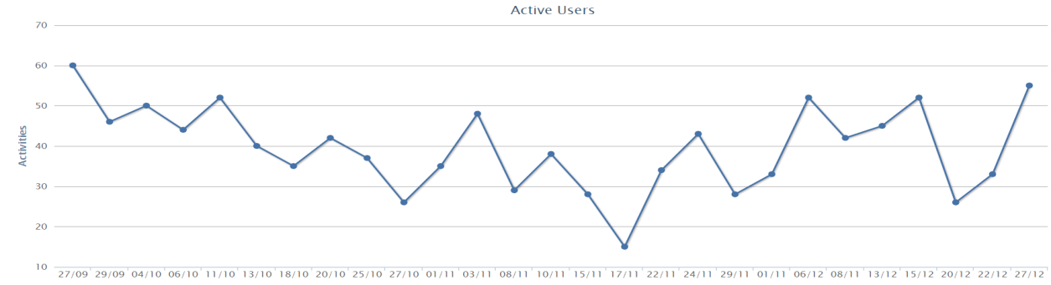

**Figure 1.1:** Student-Teacher Activity Ratio (Advance Database Management System, Section- [A])

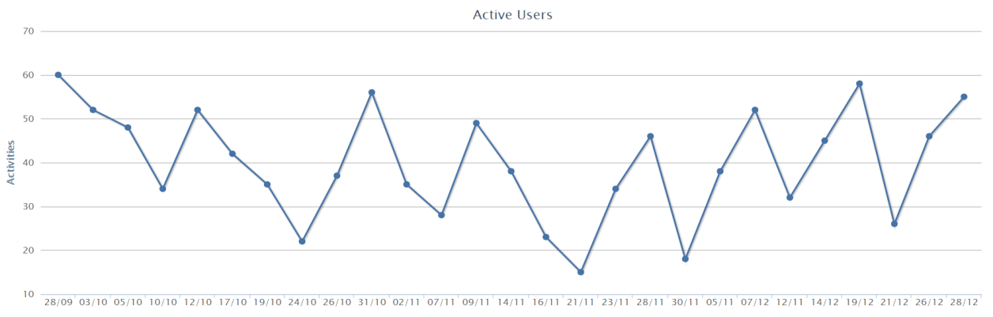

**Figure 1.2:** Student-Teacher Activity Ratio (Advance Database Management System, Section- [B])

* 1. **Background:**

We know that American International University – Bangladesh (AIUB) is one of the well-known or reputed the private university of Bangladesh that was founded by Dr. Anwarul Abedin in the year 1994 [1] by government approval. The name of this university was AMA International University Bangladesh in the beginning time, but it was a combined venture between AMA Computer University of the Philippines and our native sponsor Dr. Anwarul Abedin [2]. But the regular academic classes are started in 1995. Then, in the year 2001, after releasing the partnership of the AMA Computer University authorities were decided to change the name of AMA International University Bangladesh and they decided that the new name is American International University – Bangladesh (AIUB) [3]. Because of a self-governing institution American International University – Bangladesh (AIUB) has a Board of Trustees and Dr. Carmen Z. Lamagna is the present Vice-Chancellor. There, students can finish their educational journey by doing one or both Undergraduate and Graduate programs from there. So, at this moment, AIUB has four departments for both undergraduate and graduate programs, such as they are the Faculty of Science and Technology (FST), Faculty of Engineering (FE), Faculty of Arts and Social Science (FASS), and Faculty of Business Administration (FBA). For this reason, this university is more demandable by giving their excellent result based on their instruction programs that are respective to by developing all difficulties. This university has a very much satisfactory security system. Every gate has a checker and scanning system. To get entry into the campus students has must punch their ID cards. Moreover, AIUB is ranked as a World University by UNESCO in the International University Handbook into the edition of 2006 [3].

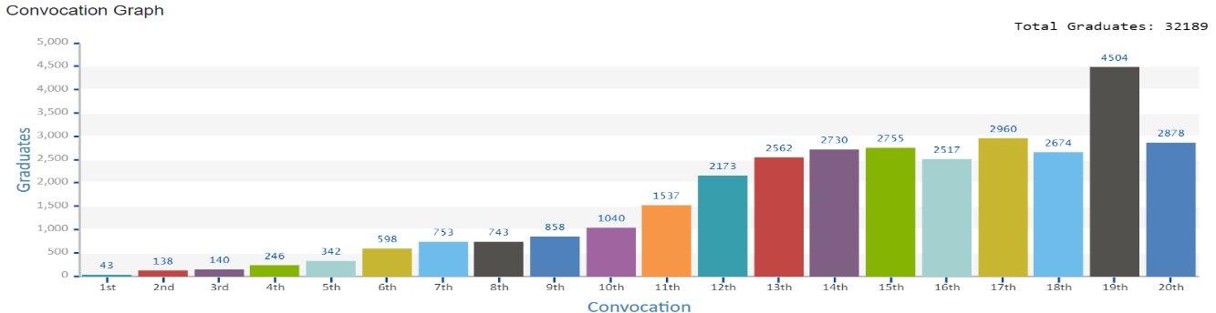

**Figure 1.3:** Convocation Graph

* + 1. **Vision:**

It is known that every educational institution has its vision. So, as like every educational institution, the American International University – Bangladesh (AIUB) has its specific vision that is mainly indicated to appoint all the needed advanced experts and fabulous, astounding, or outstanding administration who can act as a leader and they take or create an account for technical or mechanical progression and improvement whenever it is needed for the nation. For this reason, they must need to develop them faster, carefully, and precisely so that the leaders are capable to create or attend any kind of meeting pluckily. Nowadays, AIUB is mainly very much focusable to give excellent quality and the unbelievable Personal Computer (PC) based scholastic projects which will be receptive for arising matter that is arrived in several times [4].

* + 1. **Mission:**

The mission plays an important role for every educational institution because it is the backbone of that institution. Therefore, American International University – Bangladesh (AIUB) has some mission as like other institutions that AIUB is decided that it will provide the high-quality and excellent, better, and innovative all computer-based programs academically which must be capable for responsive for all emerging and upcoming challenges, or issues that can arise at any time. Moreover, AIUB is also committed or dedicated to providing nurture cultivating and producing all upcoming competent that will be world-class or excellent professionals imbued also with the strong and capable sense that must have the ethical values to get ready to face all types of competitive difficulties, a world of arts, social science, and mechanical or technology [5].

* + 1. **Goals:**

Being a well-known and reputed university, the American International University – Bangladesh (AIUB) has surrendered or decided for interpreting or explaining themselves by their activities into the programs, ventures, and all related exercises which is more feasible to convey all of the quality of administration frameworks. Therefore, all the students will start to esteem all clients who are staying in the central center of the university, and they might be trying to give extreme care and consider meeting with their pristinely needed and future position victory [6]. For this reason, to implement all these things, their goals are such as-

* Sustain, or maintain the development and progress of the university or academy.
* Continue for upgrading all educational services and facilities responsive which demand for changing and all needs for the society.
* Inculcating all the professional cultures which are the management, workforce, faculty, and personnel into the attainment that is from the institutions’ vision, mission, and goals.
* To enhance the research that consciousness into discovers new degree for all curriculum development and also enrichment.
* Every implementation should meaningful and relevant to the community area to outreach programs that are reflective of the available resources and the expertise of the university.
* Accelerate all the participants who are alumni, students, and professionals during the implementation of educational occasions and improvement worldwide scholarly norms [7].
  + 1. **Motto:**

From the beginning time till present period, the American International University – Bangladesh (AIUB) is proved their adoring, and unique witticism, “Where leaders are created” by earning with their hard work and perseveringly to create their pioneer position into the corporate world.

* + 1. **Quality Policy:**

American International University – Bangladesh (AIUB) is always tried to make no trade-off regarding their quality. So, the quality is a clung that is similar with the indorsement public and international principles which have value and greatness including given all those by the expert corpora and organizations. Here the focal point is the understudies of the university and must have to give extreme all considerations with their desire goal which they will get from their crude requirement that will be a significant achievement for the future vocation. For satisfying that responsibility, the AIUB try to apply the best endeavors for the ring of its activities into their congruity with joint effort, by participating and interviewing with each of the unit and segments of the University [7].

* + 1. **Linkage & Networking:**

The American International University – Bangladesh (AIUB) always tries to maintain and hold all their present linkages that relate to many national and international programs and organizations. Those organizations are mentionable like [8]:

* Certified Internet Web (CIW) Professional Program.
* The Duke of Edinburgh’s International Award.
* Microsoft IT Academy.
* Education Partner of Bangladesh Cricket Board.
* Oracle Academy.
* Microsoft Security Cooperation Program.
* Authorized SUN Education Centre.
* MSDNAA.
* CTP Authorized Training Academy.
* CCNA and IT Essentials in collaboration with CISCO.
  + 1. **Institutional Member:**

The noticeable thing is that nowadays American International University – Bangladesh (AIUB) has seven different types of the institutional member. So, they are such as [8]:

* Association of Management Development in South Asia (AMDISA).
* Global University Network for Innovation (GUNI).
* International Association of University Presidents (IAUP).
* Asia Pacific Quality Network (APQN).
* American Association of University Administrators (AAUA).
* International Association of Universities (IAU).
* Association of Universities of Asia Pacific (AUAP – Board Member).
  + 1. **Member:** The American International University – Bangladesh (AIUB) is feeling very much proud because it is a member of the following two different organizations. The name of, those organizations are [8]:
* Association of Management Developing Institutions of Bangladesh (AMDIB).
* American Chamber of Commerce in Bangladesh (AmCham).
  + 1. **Facilities at AIUB:**

University is a source place which is full of huge knowledge. Therefore, the University generates or raises newly originative, and creative knowledge, abilities, proficiency, and in the momentous appointment. By quenching the thirst of educated of those seekers or students will get exceeding expansive horizon of the learning and the encountering or envisage fresh or newly obstruction or barrier that is come from a life that is solved and finds accurate defining expectation from the American International University – Bangladesh (AIUB) that even solved in the season of this commencement or inception.

Besides, both undergraduates and graduates can be honored and encouraged by their work, their contribution and that toward them to become leaders in their own preferable department or area. Additionally, for consistent transform for the students is going through dynamically of all members who are involved in the development procedure, they are inlaid through both academic and extracurricular or co-curricular activities. For this reason, it is established and keeps up or maintains their accruing reputation from the time of starting is a pioneer in the pursuit of all to the excellent and magnificence. At the elementary time, all the students come forward to continue their study and get benefit from the university assets and propulsion or administrations. Therefore, the guidance is under of surrender or committed and visionary builder or founders, energetic propulsion, amply equipped workforce, and competent care of staff, the foundation can continue by the catalyst which is for change and promoter in the several varieties of an area of endeavor. For accommodating the coming interests of the different times and the requirement of the students of this intuition is become equipped by enough of the numerous high-class officers.

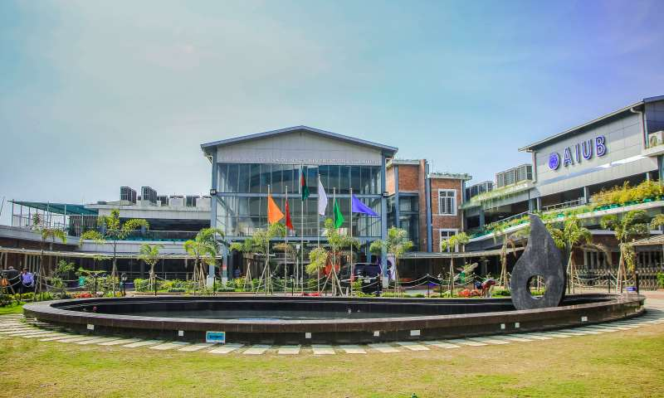

**Figure 1.4:** AIUB Permanent Campus

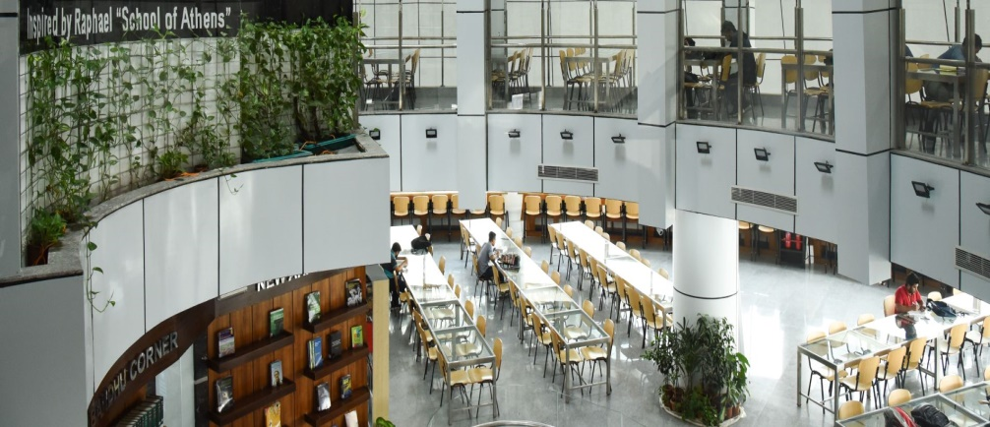

**Figure 1.5:** AIUB Library

* + 1. **Co-Curricular Activities:**

Besides all academic education, extracurricular or co-curricular activities play a significant role in student education life. For this reason, American International University – Bangladesh (AIUB) highly encouraged students for extracurricular activities by giving several competitions like programming competitions, rover challenges, photography competitions, chess competitions, and so on. AIUB CS Fest, Gaming Fest, a job fair, and Business Week are normally hosting those events. Additionally, all participates can also participate alongside other universities. Besides, there have some sporting events that are hosted by the AIUB Cricket World Cup, and the AIUB Football World Cup. Therefore, the American International University – Bangladesh (AIUB) has several organizations or clubs as like:

* AIUB Photography Club (AIUBPC).
* AIUB Cricket Team.
* AIUB Computer Club (ACC).
* AIUB Social Welfare Club- Shomoy.
* AIUB Oratory Club (AOC).
* IEEE Student Chapter
* AIUB Community of Engineering Students (ACES).
* AIUB Performing Arts Club (APAC).
* AIUB Drama Club (ADC).
* AIUB Foreign Student Association (AFSA).
* AIUB Business Club (ABC).
* AIUB Football Team.
* AIUB Art Club (AAC).
* AIESEC at AIUB.
  1. **Objective:**

We need to finish an internship and must present our internship report appropriately so that we can get our certificate Bachelor of Science (B.Sc.) in Computer Science and Engineering (CS) under the Faculty of Science and Technology (FST). This report will assess my work and it is the record of the works I have done during my internship. Moreover, the purpose of an internship program is to enable and encourage students on their career advantages and opportunities. The complete curriculum qualifies for offering students the opportunity to study, observe, and choose their objectives and points. My objective was to smooth and clarify my scholastic information and involvement with a fledgling to gain proficiency with the best practices to accomplish the objective. Besides this, there are many objective parts of it. Those are,

* To know how to connect with the students.
* To gain knowledge of the professional environment.
* Maintaining work under pressure and in serious condition.
* To prepare me for my future career.
* To know how to teach and conduct with students.
* To know about establishing teacher-student communication effectively.
* To know about maintaining as well as managing work within a specific duration.

1. **ACTIVITIES**

For completing the undergraduate program an intern student needs to do many activities related to his work. Generally, the undergraduate program has some actives and obligations, which need to keep on completing this transitory work and students must follow those. As far as to plan I have also assigned those activities and from there the most important part is the internship period. This is very important for an intern student to complete the internship period with care and more attentively. Basically, in this period student must prepare himself for professional life and professional work. During this period students need to show all skills and apply them to the work that they learned from their undergraduate study life. As an intern student, I had two opportunities to complete the internship period. The first one was I could have done my internship outside the institution in many industries area. The second one is what I have chosen which is working as an intern student under the institution allocated in a section. I have applied as an intern student at the university and sent my CV. They had given me the golden opportunity to work as an intern student. After considering my CV they appoint me as an intern student under the Advance Database System lab. Here is my appointment letter below.

**Figure 2.1:** Appointment Letter

### Work-Related:

I was appointed as an intern student and worked in the lab as a lab assistant. As I was an Intern Student, the Computer Science department allocated me to two labs as they prefer. I needed to attend those two lab classes of Advance Database Management System, section [A] & [B]. In this time, I have also accomplished firsthand experience regarding educating, understudying the board, and so on. Each lab class, duration is 3 hours where I need to attend. During this period my duties were to gauge participation from Microsoft Team's participation sheet and put it to reviewing the dominant sheet, checking the attendance, checking task entries, checking copyright infringements, and helping them in several works. I usually help them with the lab work as well as project tasks. My regarded personnel were truly liberal and thus much supportive so that if I confronted any troubles during the lab, he had helped me. I needed to check whether the students are dealing with issues in the lab or who face troubles in understanding the lab task. During the lab time, a few students get mistakes in their code, then I need to help to tackle them as well as suggest them in the easier way to solve the problem they are facing. The educator additionally recommends how to work on me if I have any missing and it was an exceptionally certain climate and accommodating for me. As I was in a virtual classroom after the class ends a few students knock me into the teams and share their problems regarding the topic studied earlier. As a matter of first importance, the course educator has covered the points, and afterward, he requests that students settle the issue. Some student was not satisfactory with regards to certain themes or occasionally I confronted them that they are befuddled that how to tackle the issue. This strategy might appear to be slow; however, it yields better outcomes as I see the amount they know before I can address their inquiries. At this time, I had the option to give a precise reaction so that they can comprehend their concern better. Most of the students are doing great in the class but a few students need fundamental information and I need to discover them and need to work on their fundamental abilities. To speak with the students, I needed to think often about verbal and non-verbal correspondence so students can understand without much of a stretch what I am attempting to say. It was difficult for some times because I was new in this profession, and it has hesitated for me to cooperate up with everyone. Working under a supervisor also, directing the students as indicated by the directions of the supervisor assisted me to work as a group.

The director under I worked additionally recommended to me how to develop myself on the off chance that I have any missing and it was a positive and supportive climate for me.

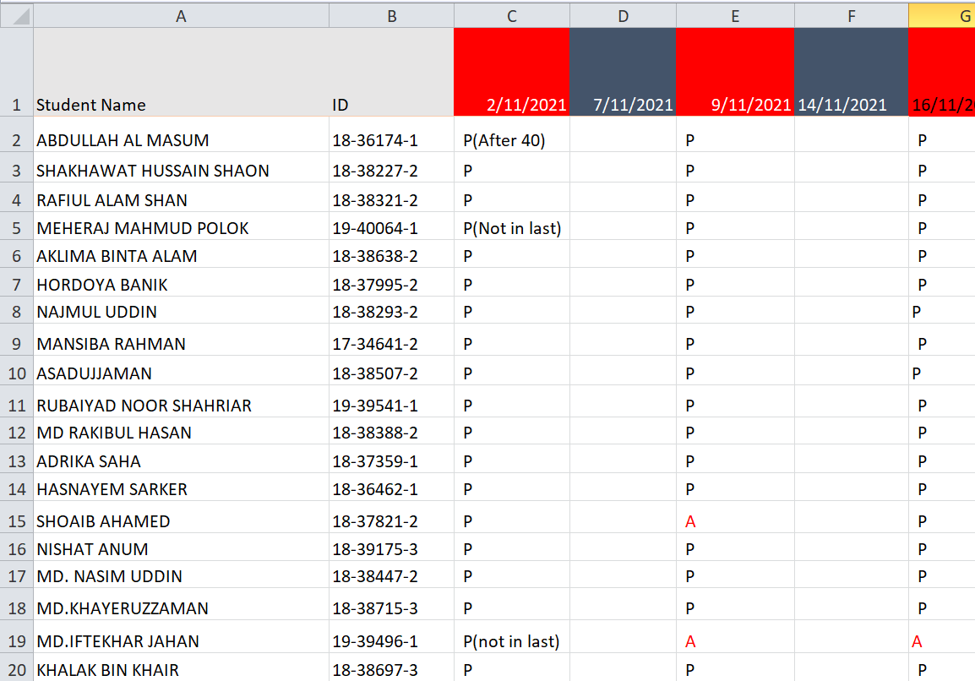

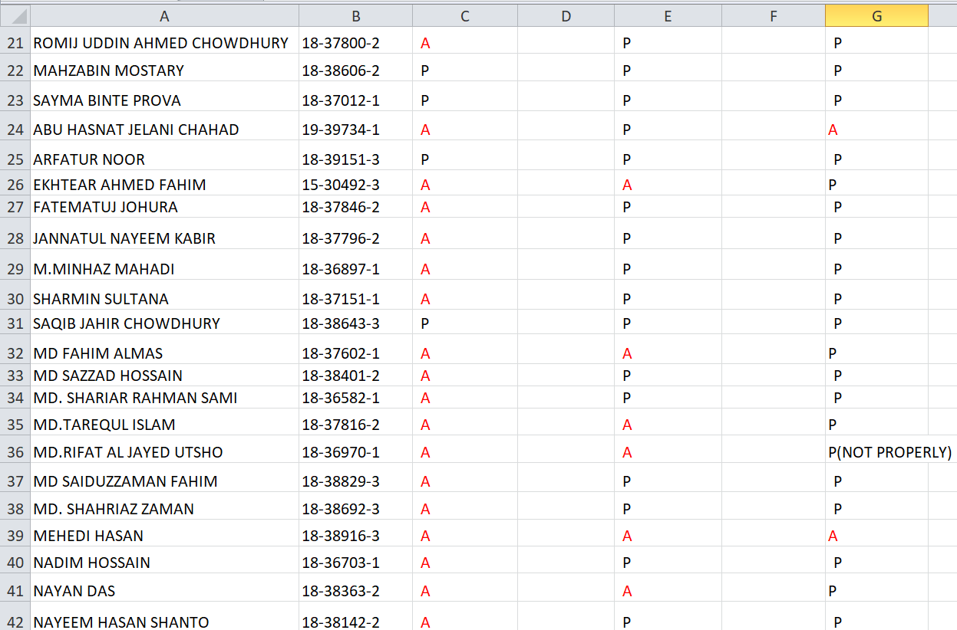

**Figure 2.2:** Taking Attendance for Section: B

### Organization-wide:

I was directly assigned as an Intern Student and got the golden opportunity to work under the faculty of science and technology allocated to the Advance Database Management System. My working department is in virtual labs through the MS Teams. It can be said that the Department of Computer Science at American International University -Bangladesh is committed and providing all the student's educated students with world-class industry and research-oriented with all proper facilities. Laboratory works play the most vital role in the field of computer science because all those implementations are very important for the students to practice in their lab. I was assigned two laboratory courses of two different sections. As this was a virtual class program so it is mandatory to use some online platform to perform classes. AIUB is giving the best platform “Microsoft Teams” to the students to get the full support of offline classes. As my working, the department is in the online lab class. So, I had to join the class online through Microsoft Teams in the class period regularly. I was assigned as an Intern Student at the Lab for the course Advance Database Management System section [A] & [B]. Every week on Monday, I was assigned as Intern Student and the timing is 11 am to 2 pm and Tuesday from 08 am to 11 am. My main and most important work here was to help the students and communicate with them when they do not understand the topic. In addition, my task was to look up to them whether they face any problem or not. If they have any problem, then I tried to solve this or try to help them to understand the topic. Sometimes they need advice for their study I also tried to give them some advice. Some students then did not understand how to install Oracal10g I help them and show them how to install Oracal10g for the Database. Sometimes students faced problems in writing code in Oracal10g, so I had to help them with that. I tried my best to help them, and I am available in time in every lab for them. I have gained some professional skills like how to communicate with students how to deal with a difficult situation. It also helps me to gain the skill that how to work under faculty supervision, how to teach students, and how to communicate with them. It helps me a lot because if someday I can be a faculty, then it helps me a lot because I have observed here very closely that how I need to teach properly, how I need to communicate with them, how should I behave with them. Before the internship, I had no experience that how to work with a faculty and how-to advice students, and how to deal with them. American International University–Bangladesh (AIUB) always keeps up with every one of the rules and they are very strict about their rules. All these rules are according to the courses of action. That’s why it was important for me to obey the rules properly and develop my skills at a high level.

### Other relevant activities:

Most importantly it is proven that an internship is a useful experience for all students in their carrier. During my internship period, I have gained new knowledge, improved my skills, and met different kinds of students to understand their point of view, and helped them several times in their tasks and other things. As I have worked as an intern student, I achieved much experience in achieving my goals for the future surely. From that point of view, I understand that the internship is a better platform to find out what are the strengths and weaknesses points of our workplace. This internship not only helped me to define what skills and knowledge but also help me to improve my skills as well. This internship is the best option for all students to achieve goals and set their targets. An intern student is mainly assigned under a faculty and works under a teacher’s guidance, to give students more facilities and help them solve their problems, helping all the students in different situations. As an intern student during my internship period, I have gained a lot of understanding that how to work with the teacher and how to solve any problem. I can say that I gained so many things along with proper experience in the teaching profession. I have had a significant amount of student engagement on a variety of levels, including assisting, advising, and offering feedback to students in their needed time. I also get the skill of how to maintain a classroom, interact with students, understand their problems, and provide proper feedback according to their problems, and properly advise them and direct them in the right way. At last, it can be said that all my internship period, I have prepared myself for the future challenges in workplaces and handling all the critical situations and shown my skills to the students by interacting with them and improving my communication skills. My assigned supervisor was open-minded and so friendly. So, working with him is my pleasure. I learn a lot from him that how to teach a student, how to interact with them, how to control the difficult situation, and lastly the punctuality that will help me in my future career.

1. **CONSTRAINTS/CHALLENGES**

Internship period is the most important period to show the skills as well as gain new capability. The activity schedule is the work distribution, which I have done in the internship program. The efficiency and maturity with which a teacher schedule the activities related to a teaching determines the teacher understands of his/her work. Maintain and make schedule of the necessary tasks and allocates those tasks the necessary time and right time.

* 1. **Identified/Observed in the Organization:**

I was a student in this institution, so this climate was known to me. Working in such a realized climate like his was acceptable. But it was obviously a big challenge for me to work in this environment. Because working from home online is always challenging and specially in this pandemic condition. I must keep myself prepare all the time before attending the classes. These challenges can be categorized in different terms as a learning challenge, teaching capability, controlling the students, and many more. One might say that all along, my workforce was truly amicable, receptive, supportive, and in every circumstance, they generally help me. It is always exciting for anybody to work with a teacher with departmental issues. But it was quite difficult for some time. As a showing partner, I need to discover what sort of issues students by and large face, what task they are given is reasonable to them or not and I likewise need to discover in case I am equipped for tackling their issues or not and I need to discover the best approach to take care of their concern. I discovered a few students are confronting hardships in understanding the inquiries and a few students get blunders in their code. There are more than forty understudies in each part, and it is hard to keep up the control in the class as it is online based. A couple of understudies don't cling to any rules and rules in the class. Now and again, they leave the class and rejoin, and every so often understudies are busy with doing various works as opposed to focusing on handling issues. While checking tasks and activities, I have seen numerous understudies' duplicated tasks and undertakings. Another difficulty I confronted was that the understudies had some absence of a range of abilities. There were a few understudies who don't depict the task's answer intricately rather they simply express the arrangement and finish. Finally, I need to say that, before the classes, I needed to set myself up, practice every one of the assignments, and about the points that were going to instruct in the following class. As it was an online class, so it was new to me as well as all the students and for that reason, it was difficult for me to cope up for a few days and after that, I have prepared myself and honestly did my duty.

* 1. **Academic Preparation:**

In the Internship time frame, it was useful for me to expand my expertise in administration. As I need to seek after a scholastic life so this experience will help me in later phases of life. As I am an understudy of Computer Science and Engineering at a similar institution, the subject I was appointed was very natural to me. It is always exciting for anybody to work with a teacher with departmental issues. Therefore, it was extremely a difficult domain for me. Before consistently I needed to keep, set myself up which was given by Students. It helps me a lot because if someday I can be a faculty, then it helps me a lot. It helped me a great deal to increase skillful work experience that I have realized before which made my understanding base solid for what’s to come. Before class, I needed to get myself ready for the class so I can respond to the student's inquiries accurately and cause them to comprehend the issues. It is never conceivable to cause them to comprehend if one doesn't think about the subject. To cause students to comprehend one needs to set himself up appropriately, else, it is difficult to make them comprehend. One might say that my administrator appropriately directed me so I could make everything simpler and smoother. As per my scholastics, I have completed a few activities that are identified with my course, and all are effective undertakings. However, this present reality project is unique about those ventures. One might say that our respectable resources have shown us numerous things that are principally founded on genuine issues so we can adapt up to any circumstance and any sort of improvement work. Our scholarly information predominantly assisted me with adjusting to the circumstance. I have completed a couple of social occasion projects adequately. In any case, this current reality moral story is extremely interesting corresponding to those circumstances. In my scholastics, I need to cause the reference to that our important assets to have taught us that particularly reliant upon that we can conform to such a condition. Our academic data fundamentally helped me with accepting the condition. Filling in as a Teacher Assistant, I have adapted so many new things without anyone else and from the students who face various types of issues.

* 1. **Personal/Professional Skills:**

In the time of my internship period, I have gained many professional skills like how to solve problems, how to communicate with students, how to interact with them, and so on. It helps me to learn how to work under faculty supervision, how to teach students, how to complete work in time. It helps me a lot because if someday I can be a faculty, then it helps me a lot to show my teaching personality. Before the internship, I have no experience that how to work with a faculty and how-to advice students. It's not possible for anyone to learn capable capacities in an establishment situation. Exactly when I recently started my work, I had no master capacities to complete my work. I had no idea about the teaching profession. I expected to defy various issues on the most capable technique to achieve the work expertly. As I have completed the Advance Database Management System, three semesters ago and there was no practice of the course after that. For that reason, in the beginning, I have faced a little challenge during this internship because I forgot some topics. On the other hand, I had the lack of proper skill to make someone understand the problem. As the teaching profession is completely based on skill and knowledge and I lacked that that’s why it was difficult more me then. The more one can make others understand more he knows, he/she could be an outstanding teacher. At the very beginning, I had to face some problems but after completing 2 or 3 classes, I successfully overcame the obstacles. Where I had a lack of knowledge and I face problems, I worked on the topics, gain more knowledge and practice more. My honorable faculty helped me to overcome the situation and he suggest to me what I should do then. In that way, I overcome the problem I face during my internship and completed the internship successfully. In my academics, I have completed several projects works successfully. After completing my internship period, I can confidently say that my skills get higher and smoother, and I have learned a lot of new things. Besides this, I must improve my communication skills and other responsible duties because I think that this is not the best yet. I think after completing this I must work more and more for my future success. Despite the way that this work was trying, it moreover urges me to get huge public talking capacities which will grim help me later.

1. **ACQUIRED KNOWLEDGE**
   1. **Consequences to Organization:**

At first, because of the Internship course, my internship position was as an Intern Student in the lab classes of the Computer Science and Technology department at the American International University-Bangladesh (AIUB) which was fraught with pleasurable, delightful, and recollection, or memorable time for me in my entire life. From my entire learning and experience point of view, gladly, it must say that I enjoyed my whole internship period goodly. With huge eagerness and optimism, from the premier day, I was sure that this job can help me comprehend my future career life along with lay bare a well picture university life in the future period. So, without losing a single day I try to work and learn because I am too much sure that that three-month Internship will give me the entrance level of position with understanding my future carrier life into the job or work market like an academician. Genuinely, I try my best to explain and write the most relevant things from my whole earning experience into the Internship Report, but all those things are not enough or sufficient to express, explain, and measurement perfectly in this concise time of my internship program. For this reason, everything might be not so much satisfactory, but I try to give my best effort to learn and assets. During the time of my internship period, I can say that I give my best effort to learn and also recall that things which I already know and new things, in the same time I try to deliver my acquiring knowledge to the students that I already gather from my other different courses with my assigning course. At the same time, I am familiar with huge fresh or new things that were the main and noticeable things in my internship program, and those things are briefly discussed by my supervisor in the assigning sections smoothly. I learned time management, how to deal with a student that is nearly 45, how to deal with the pressure of the whole classroom, how to introduce a new topic and present it, and how to communicate with all the students frequently. So, this whole organization or program teaches me how to earn, learn, and hold patient all time. Therefore, with pride and pleasure, I can say that my supervisor gives me his complete support with his patient and the proper guideline that I need badly. While I made any type of mistake, he calls me to understand the better way that thing and give me another chance for correcting with any types of bother. At the time of my internship program, I give my whole effort to assist all the students by giving suggestions, solving their problems, and their curiosity, and understanding their problems or issues as soon as possible with my friendly behavior and with the help of my supervisor. For this reason, I can say proudly that I am very fortunate and pleased because I am finished my internship as an Intern Student at the American International University-Bangladesh (AIUB) which is a leading university in our country beside I learned how to work professionally with patiently fulfilling all the responsibility.

* + 1. **Culture:**

Every institution or association have their design or way of managing their present position. So, the American International University-Bangladesh (AIUB) has a department named Computer Science and Technology which has not any excluded for that position. For this reason, the working place has its own lawful or legitimate culture. In modern times, I can feel that I am comparatively changed their and my lifestyle within the last few days. Therefore, I acquired an enormous update in my self-metering condition than previous. Here, the most noticeable thing is that I am progressed my previous and present conviction level in that way, which can give me covered support during my working time properly with the given instruction. Moreover, I have gained some good manners that are the hang of taking care of time properly, working under pressure, and solving different problems of people.

* + 1. **Working Environment:**

The Working Environment is a wonderful, amazing, and unspoken division that is built for getting proper instruction and learning circumstances. Therefore, the educationalist who are likewise want to the understudies, this is excitation there. All knew that a pleasing or nice environment can be achieve excellent preparation. If the working place is home that brings the untold pleasant environment and gives great experience also. Because of the online internship opportunities, I give my best outcome timely and perfectly. There the most momentous things that they assign me both same courses under the same faculty that was very much painstaking for my work, assist and learn. For this reason, I can clear my concept smoothly if any problem arises. Additionally, all official lab classes were very much helpful for me as an internee. As an intern, I was taught that how to work ethically whenever a raised degree arrived at the workplace that is why this internship brings to me better training. Every educator must need to get a permit to show their understudies whenever some irregular level of squeezing factor comes to them. My executive or organizational supervisor is very much privileged by supporting me and carefully handling me if I made any mistake during my internship period, and he never raised any kind of hell, but he tried to solve the mistake diligently. For this reason, the internship program is taken across smoothly to me and very much adjuvant.

* + 1. **Communication:**

Communication is a process that acts like giving, receiving, and sharing all the information with others via words, or talking. In the whole internship period, the most precious thing is the way of communication with the student and organizational supervisor also. Therefore, this official program is significantly navel on analogous that how they learn toward virtual similarity in today’s situation. As an intern, my work was to help all understudies in their learning and understanding. So, via “Microsoft Teams”, I started my communication with my students and my supervisor also.

* + 1. **Students and Faculty Members:**

American International University-Bangladesh (AIUB) is an education that has 12 thousand understudies that are all out in the excess and are involved in various projects at present time. Here, all the students or understudies are mainly educated by the absolute more than nearly 300 well-effective professors under numerous officers.

* + 1. **Time Management:**

At first, one of the most significant, helpful, and good things that I am gained from my experience during the internship program is Time Management. This Time Management gives me that how to handle and manage time whenever I must stand up to any type of significant problem that is directly connected to my work and study both. For this reason, I can say that I need to learn time management badly forasmuch I was faced some problems during my previous work and study time.

* + 1. **Professionalism:**

To become a popular and successful specialist, this professionalism partition or allocation trained me properly during my working or internship period by noticing my working technique. By the cleaned approach, this partition is particularly emphasized by maintaining the standard and fulfilling all the necessities. In this way, they are nicely gone through anyway with their capability during the educational skeleton. Mainly the certifiable ability grows whenever the viability and decrement are mix-ups, and which come to ensure and get whole quality according to the limit of understudy assistance satisfaction. Therefore, it can connect people to me via being exact, lessening oversight, and noticing all the regulations as person demand.

* 1. **Implications to University’s Internship Program:**

The impermanent or temporary occupation is an occupation that is built with realistic experience which mainly occurs between and during any period of the institute. Therefore, the American International University-Bangladesh (AIUB) grants me the permit for applying a significant part of the data that I gained during my internship period and urges me to get more happiness into my work. For oncoming Interns this institution will be gathering empowers which also gives me and that was an incredible arrangement for me which is to get experience in this portion or section level program. Now, the present standard of this university is high from other universities in Bangladesh. Some other universities did not add Internships as compulsory credit in their curriculum. For this reason, I am very much thankful to our university and the Faculty of Science and Technology for making the internship program a compulsory credit into our graduate program with a goal. Besides them, I will additionally be thankful to our CS office who is giving their full support for getting successful this internship program. Therefore, this internship comes with a major chance for me to complete my Bachelor of Science (B. Sc.) degree at American International University-Bangladesh (AIUB), by showing everyone that I can discover all the lacking that already I have, I could be undoubtedly known and realize in which course I need to be study and clear concept again. Here, I try to make my honest effort to my work into each basic official class and climate. Whenever I accept my internship as an Intern Student at AIUB, I feel very much excited to work with our respective faculty and the students. Therefore, this internship program has become more satisfactory to me because it provides many facilities for their employees and interns and that is a great benefit for any type of career, as well as if I want to be a faculty. Additionally, I also want to express my gratitude to my industrial supervisor and those who have given me this opportunity and supported me in my internship program.

* 1. **Effects on Personal/Professional Skills:**

For both of my personal and professional skills, this internship is most important and efficient. During this internship period, I learned how to interact with students, how to communicate with the students from my perspective faculty. Currently, I am facing a lot of new challenges. Those challenges occur because of difficulties someone understands a thing or processes properly. Before doing the internship program, I have a lack of communication skills and make someone understand the problem, but this program teaches me those things and improves my quality. After that, I worked on topics where I had lack of knowledge and give consult the student regularly to better understand their problems. Therefore, successfully I overcome my problems and completed my internship. At the same time, I figured out how to maintain office time any personal time and how to work carefully that is given me become an expert professional career. I realized that the main goal of this internship program is to get practical work experience by assisting a teacher. Moreover, I learned from this internship program many valuable things. Some of the valuable things are-

* Communication Skills
* Work Ethics
* Analytical Skills
* Problem Solving Skills
* Creativity
* Time Management
* Public Speaking
* Planning Skills
* Teach confidently

1. **CONCLUDING STATEMENTS**
   1. **Summary:**

American International University-Bangladesh (AIUB) is one of the most prestigious universities in Bangladesh and the Department of Computer Science provides a good educational environment for both Undergraduate and Graduate programs. I am thankful that I am a part of this prestigious internship program, which is arranged by this department. The internship program essentially gives me the capacity to consider, acquire abilities, and gain experience. This internship program permits me to handle the entirety of the impediments, tackle them on my own in new specialized difficulties, and work on my scientific abilities. Filling in as a teacher's helper assisted me with turning out to be more confident, exceptionally able, dedicated, and dependable which is why I need to thank the college organization and, specifically, my directors for giving me a particularly incredible chance to function as an educating associate. The information and experience that I have accumulated by functioning as an Intern Student in priceless to me and subsequently I might want to offer my thanks to both my industry and scholastic managers for their guide and help. I might want to additional offer my appreciation to the Faculty of Computer Science Engineering for allowing me a chance to finish my entry-level position effectively This report is all about the representation of my internship program. This report presents the experience that I had gain during my internship program. As an Intern Student. Working with my supervisor is the best part of my internship program period. Because they are too much helpful a friendly too. They help me in many ways and supervise me that how to work and how to maintain the class and maintain the situation in a class. They teach me how to collaborate with students and other faculty. So, it is helpful for my future career. I am also thankful to my academic supervisor because without his instruction it is not possible. He provides me with how to write an internship report properly. A student can have just scholastic ability before the internship, however, after the internship, the person must have specialized capabilities and experience.

* 1. **Recommendations/Suggestions for Future Strategic Actions:**

I think that this internship program is a great opportunity who wanted to come into the teaching profession. I am very thankful that I have the opportunity to enroll in this internship program. I am also thankful to my supervisor. This program is good enough but can also be a better program. I think if students are feeling free to do the work under the supervisor, then it is best. However, sometimes it is boring also because all the time must seat in my chair and stare at the screen of the laptop. It is necessary to evolve interns in more works so that they can learn more about professional works. It would be better if it can be implemented as early as possible. It will be very helpful for jobs their career. Finally, I would like to share that I have enjoyed myself a lot during my internship period.

* + 1. **Organization:**

An organization should provide an intern with the opportunity to serve in their preferred field rather than assigning small tasks and they also should give facility to the intern what they need. The online instructing nature of AIUB was adequate. Although in some cases web speed was not sufficient both on the workforce and understudy side the working experience is great.

* + 1. **University:**

The internship program of the universities is appropriate, and it is perfect. But it is necessary to train the interns more and more. So, it would be more beneficial for the interns if they are assigned to the courses in which they are most involved. Therefore, I'm pleased that I got an opportunity to do my temporary position as an intern student at my university. To Study here was my dream and like that it was also my dream to work here. I am pleased that I have got that opportunity. The working environment is great here. In conclusion, the university has an excellent career scheme for internships and Intern Student positions.

* + 1. **Personal/Professional:**

To become successful in professional life must have to work hard, be responsible, sincere, and smart in working. Future learning and research facilities will be expanded. Students at my university will participate in internships. Internship teaches how to be punctual in personal and professional lives. It helps to cope up in a difficult situation. It's not easy to cope and adapt to a working world, so I'm forced to work longer and longer hours. Various roles and obligations of mine advised and judged me daily during my internship. However, it would be preferable if all intern students were mentored together and given further training for their roles and obligations during the internship term. Enable them to take more lessons to improve their skills.

**RECOMMENDATION LETTER**(*A recommendation letter on the letter head of the organization from your organization supervisor*)

**REFERENCES**

# References:

|  |  |
| --- | --- |
| [1] | https://en.wikipedia.org/wiki/American_International_University-Bangladesh, American International University - Bangladesh, Accessed on: 3 July, 2020 [Online]. |
| [2] | https://www.aiub.edu/about/information, History, American International University - Bangladesh, Accessed on: 3 July 2020. |
| [3] | https://www.aiub.edu/about/information, History, American International University - Bangladesh, Accessed on:2001 [Online]. |
| [4] | A. I. o. O. |. AIUB, Vision, American International University - Bangladesh, Accessed on: 3 July 2020. |
| [5] | A. I. o. O. |. AIUB, Mission, American International University - Bangladesh, Accessed on 3 July 2020. |
| [6] | A. I. o. O. |. AIUB, Goal, American International University - Bangladesh, Accessed on: 3 July 2020. |
| [7] | A. I. o. O. |. AIUB, Quality Policy, American International University - Bangladesh, Accessed on: 3 July 2020. |
| [8] | D. o. C. Science, For the faculty members, Department of Computer Science, American International University - Bangladesh, Accessed on: 25 February 2021 [Online]. |

**APPENDICES**

Md Rifat Uz Zaman

209/A Para Joynagar, Singra, Natore, Rajshahi.

Email: [rifatuz28@gmail.com](mailto:rifatuz28@gmail.com)| Contact: +8801799015977

LinkedIn: @rifat-uz-zaman-61735b202

# Skills & Attributes

|  |  |
| --- | --- |
| Programming | C, C++, Java, Microsoft .Net (C#), MATLAB, Python (Learning) |
| Web Development | Html, PHP, Java Script, CSS, Node.js (Learning) |
| Database | Oracle database, MySQL, Microsoft SQL Server |
| Software | Microsoft Office (Word, Excel, PowerPoint), XAMPP, Eclipse GeoGebra Calculator, MATLAB, Cisco Packet Tracer, AutoCAD, Proteus, Multisim, Arduino IDE, Wireshark, EMU8086, Notepad++, Code Blocks, Weka, Sublime Text |
| Development Tools | Visual Studio, GitHub, Trello, Oracle |
| Operating Systems | Windows (98-10), Linux (Ubuntu) |

# Education

# American International University-Bangladesh | Dhaka, Bangladesh

Bachelor of Science in Computer Science and Engineering (BSc. CSE)

Predicted CGPA: 3.90 in 4.00 scale (Current CGPA 3.87)

# Singra Damdama Pilot School & College| Singra,Natore, Bangladesh

Higher Secondary School Certificate (HSC)

Group: Science

GPA: 4.67 in 5.00 scale

# Singra Damdama Pilot School & College| Singra, Natore, Bangladesh

Secondary School Certificate (SSC)

Group: Science

GPA: 5.00 in 5.00 scale

# Singra Damdama Pilot School & College| Singra, Natore, Bangladesh

Junior School Certificate (JSC)

GPA: 5.00 in 5.00 scale

# Volunteering

**Care for Paws | Rajshahi, Dhaka, Bangladesh**

Part-time Volunteer

Rehabilitating stray animals that have been neglected, abused, or injured. Creating awareness about animal rights and organizing campaigns on it.

**Academic Thesis/ Project**

**Thesis on Conceptual Clarity and Terminology of Hate-speech Intensity Scale (Running)**

(Using Python- NLKT, Anaconda. IDE: Jupyter Notebook)

Supervised by Md. Kishor Morol

Lecturer & Supervisor

Department of Computer Science

American International University-Bangladesh

**ESP32 Cam Motion Alert System for Real Time Security Monitoring**

(IoT based project using ESP32 cam, FTDI module, PIR sensor in Arduino IDE)

**Beauty Parlour Management System**

(UML Diagrams, Normalization, Entity Relationship, Sketch using DIA and SQL queries using Oracle)

**Crowd Funding (FundBD)**

(Using PHP, CSS, Xampp, phpMyAdmin, Java Script. IDE: Visual Studio Code)

**Rainy Day Modern Village Scenario**

(Using Code Blocks GLUT, Tayasui Sketch)

**Hospital Management System**

(UML Diagrams, DIA and SQL queries using Oracle)

**Coffee Shop Management System**

(Using C#, IDE: Visual Studio)

**School Management System**

(Using Java, UML Diagrams and SQL queries using Oracle)

# Additional Skills

Language: Bangla, English, Hindi (Speaking only)

Photo Editing Adobe Photoshop, Adobe Lightroom

Graphics Designing Adobe Illustrator

ALL rounding Cricket Performance

Expert in PI and Grant Chart works

Good at Brainstorming related work

# Personal Information

Father’s Name: Md. Hafizur Rahman

Mother’s Name: Mrs. Rafeza Begum

Date of Birth: 2nd January 1999

Blood Group: O+

Religion: Islam

Nationality: Bangladeshi

Marital Status: Unmarried

Address: 209/A Para Jayanagar, Singra, Natore, Rajshahi

# Hobbies & Interests

Photography Participated in 35Awards 2020

Gardening in own house Rooftop

Playing Cricket in 2nd Division League

Cooking Food in Special Occasion